**ASSIGNTMENT 4**

1) Write a shell script tp print

* your are logged in as which user
* in which directory you are
* and in which terminal you are working
* total number of files and directories in current directory

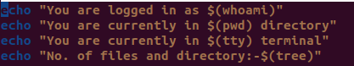

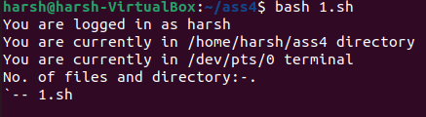

2) Write a Linux shell script to accept 10 number and tell how many are +tive, -tive and zero.

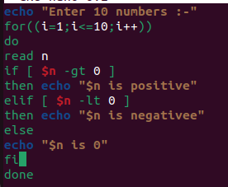

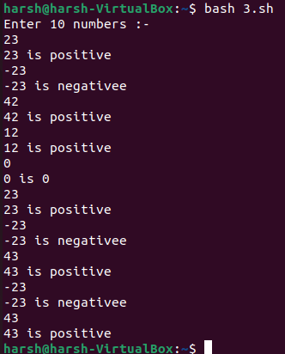

4) Write a shell script to accept five number and display max and min value.

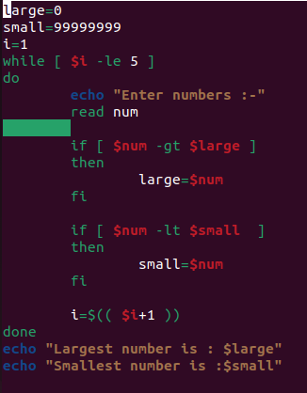

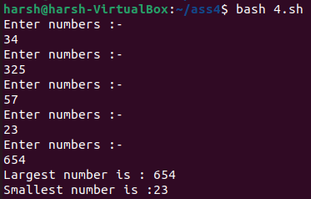

5) Write a script to find out String is palindrome or not.

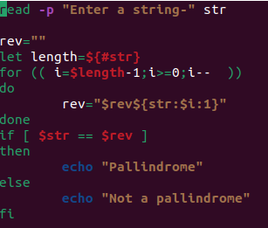

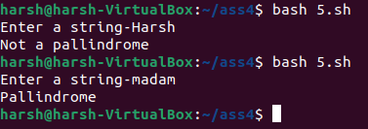

6) Write a shell script to print given number’s sum of all digits (eg. If number is 123, then it’s sum of all digits will be 1+2+3=6)

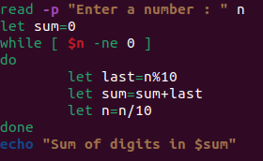



7) Create a script to

Create user , Delete user , Create group , delete Group using case

